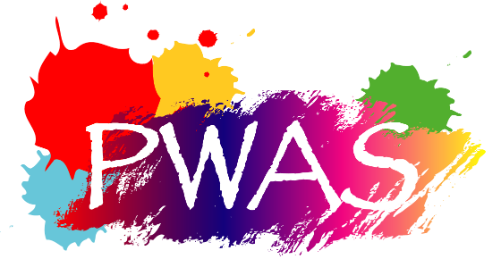
Please complete this form for the Art Showcase (online gallery) on the PWAS website.

Name:
Email:
Website, if any (optional):
Any other sites (Ebay or Etsy or where you are listed) Optional:
Mediums:
Accepts Commissions: Yes or No
Typical Subjects:
Art Biography (one or two SHORT paragraphs):

Attach a photo of yourself (optional):

Attach up to 10 jpg photos of your art – let us know the title, size, and medium for each. Please make it clear which title and information goes with which photo (mention each filename). Including a price is optional.

Do you prefer a slider format (like the page for Mark Murphy) or a grid format (like Sandra Lewin) for your artworks? ____ Slider, or ____ Grid format.

Notes:
- This is for PWAS members who have paid the small additional annual fee to have a page in the Art Showcase part of the PWAS Website.
- This is not part of the online store. Your art cannot be sold or paid for in our store. A interested buyer would contact the artist directly to arrange for purchase.
- Please provide this information in an email (to web.admin@princewilliamartsociety.com) with the photos of your art as jpg file attachments.
- PWAS reserves the right to reject your submission. Reasons could include file formats, quality of work, objectionable content, or other reasons.

